

Technical Writing Sample #5

How to make three API calls using the Hacker News API in Python?



May 8, 2018

Alvin Lawson

**Introduction:**

The [Hacker News](https://news.ycombinator.com/) API allows individuals to retrieve news information on their website:

* The ability to find the newest news.
* Find the latest comments on the website.
* Search for profile changes that a user has made.

**Prerequisites:**

Before you begin this guide, you need the following:

* You need to set up a local development environment for Python 3. [How to install Ubuntu?](https://help.ubuntu.com/community/Installation)
* A text editor that you will be comfortable using: [Sublime Text](https://www.sublimetext.com/), [Atom](https://atom.io/), [Visual Studio Code](https://code.visualstudio.com/).
* You need a [Hacker News](https://news.ycombinator.com/) account.

**What To Install:**

* You need to install Requests using PIP in Terminal.
* Press **CTRL + ALT + T** on your keyboard and type:
* **PIP install requests.**

**API Calls:**

* **GET -** Requests a resource at the requested URL.
* **OPTIONS -** Indicates which techniques are supported.
* **HEAD -** Returns meta data from the requested URL.

**Use:**

1. Copy this [code](https://github.com/al11588/MajorLeagueHackingAssignment):

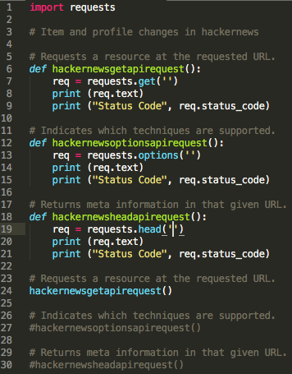

1. Copy the code below, indent and paste it on line 7 to make a **GET** API call:

“req = requests.get('https://hacker-news.firebaseio.com/v0/updates.json?print=pretty')”

1. Run the Python script and it will **GET** the information in JSON.

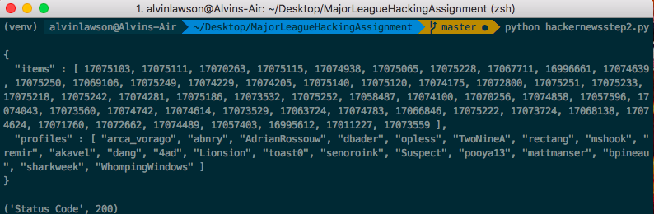

1. Copy the code below, indent and paste it on line 13 to make an **OPTIONS** API call:

“req = requests.options('https://hacker-news.firebaseio.com/v0/updates.json?print=pretty')”

1. Delete the **#** on line 27:

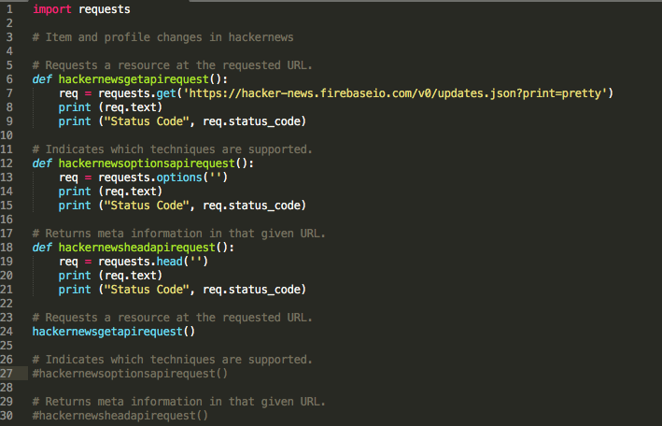

1. Run the Python script to see which **OPTIONS** are supported:

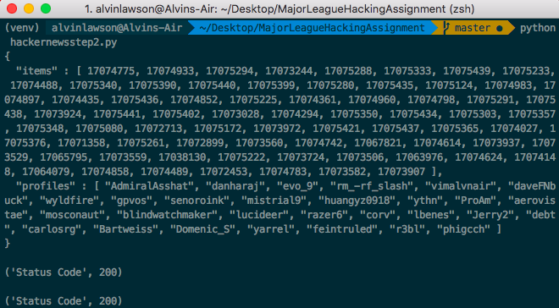

1. Copy the code below, indent and paste it on line 19 to make a **HEAD** API call:

“req = requests.head('https://hacker-news.firebaseio.com/v0/updates.json?print=pretty')”

1. Delete the **#** on line 30:

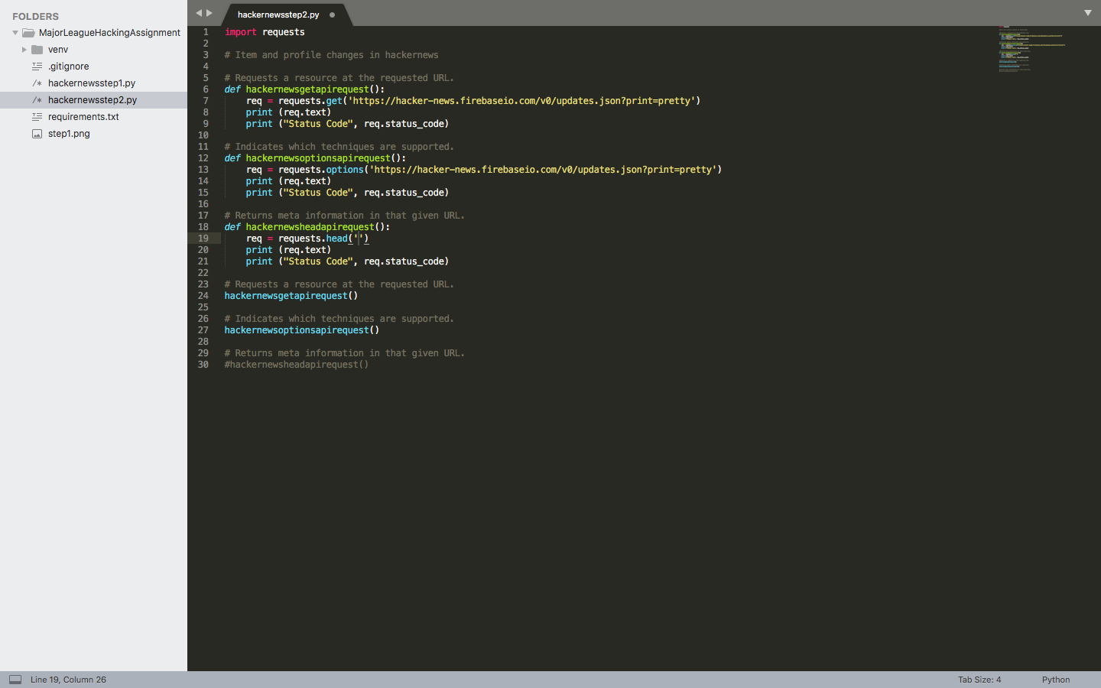

1. Run the Python script to see what meta information is available the **HEAD** of the URL:

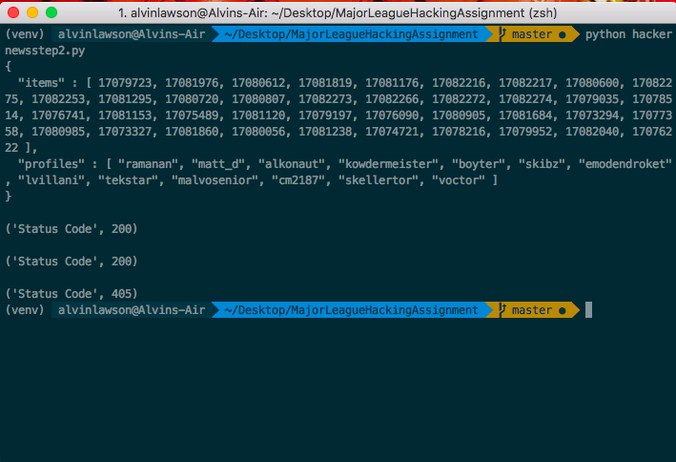

**How To Run Example:**

* **Link:** [Click Me](https://github.com/al11588/HowToUseHackernewsAPI)
* **Install:** Python 3.
* **Install:** Firefox or Chrome.
* **Run:** "pip install virtualenv".
* **Run:** "source venv/bin/activate".
* **Run:** "pip install -r requirements.txt".
* **Run:** "python3 hackernewstep2.py".